**Stores Sales Analysis**

1. **Total Units Sold by Year**

* **Analysis**: This line chart shows the trend of units sold over the years 2022 to 2024. There is an initial increase in sales from 2022 to 2023, but sales drastically dropped in 2024. The peak of sales was observed in 2023 with a notable decline in 2024, which could indicate external factors affecting sales in that year.
* **Conclusion**: The company should investigate the factors leading to the steep decline in 2024 and take action to recover sales.

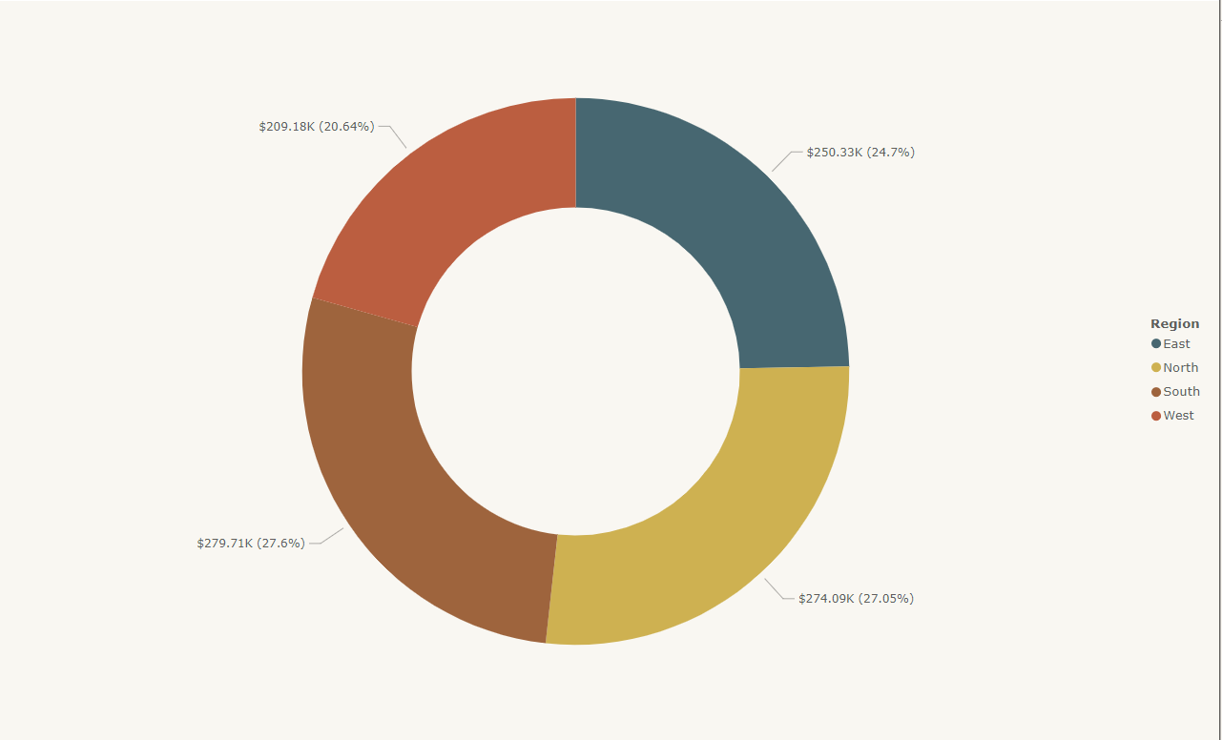

1. **Sum of Profit by Region**

* **Analysis:** This donut chart breaks down the profit contribution from different regions. The West and South regions have the highest contributions, accounting for 27.05% and 27.6% of profits respectively. The East region contributes the least with 20.64%.
* **Conclusion:** The company should explore strategies to improve profitability in the East region while maintaining strong performance in the West and South.

**4. Sum of Sales Amount and Units Sold by Year (Line Chart)**

* **Analysis:** This line chart overlays the trends of total sales amount and units sold from 2022 to 2024. Both sales amount and units sold follow similar trends with a decline in 2024. This suggests that fewer units were sold, leading to lower total sales in 2024.

**Conclusion:** There is a direct correlation between units sold and sales revenue, and steps should be taken to reverse the declining trend in 2024.

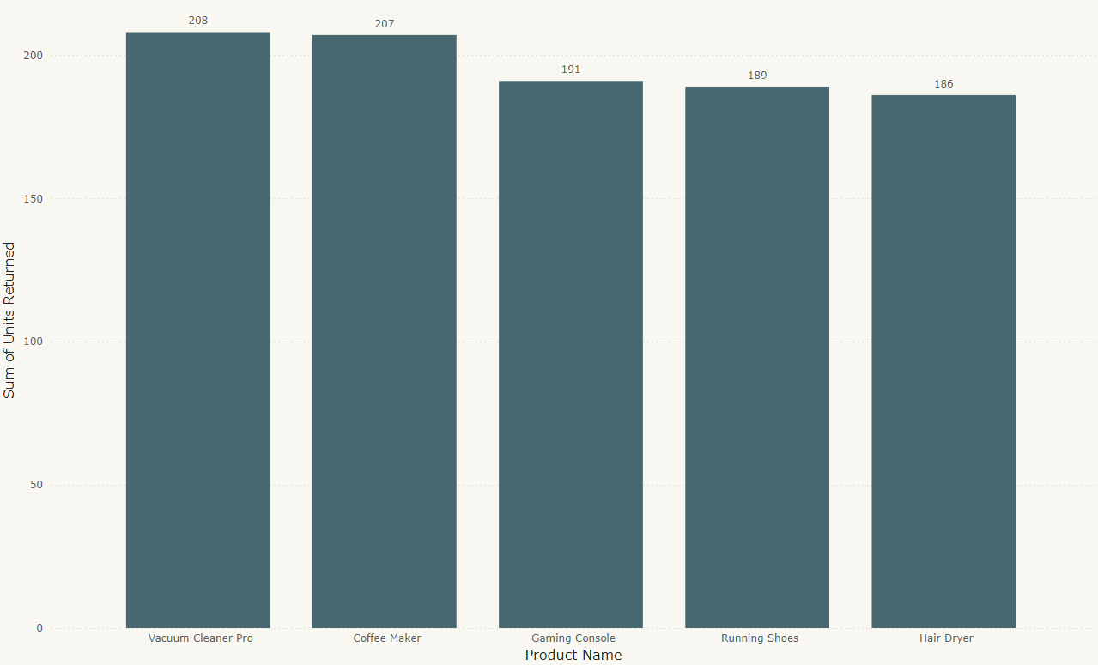

1. **Top 5 Products Returned**

* **Analysis:** The bar chart displays the top 5 returned products, with the Vacuum Cleaner Pro leading with 208 units returned, followed closely by Coffee Maker and Gaming Console. This indicates certain products are being returned more frequently than others.
* **Conclusion:** Product quality or customer satisfaction should be reviewed for these items, as they are more likely to be returned compared to others.

1. **Sum of Units Sold and Units Returned by Product Category**

**Analysis:** This chart compares units sold and units returned for different product categories. Apparel leads in both units sold and units returned, whereas Electronics and Home Appliances have fewer returns relative to the units sold.

**Conclusion:** The company should look into strategies for improving the performance of high-return categories, especially Apparel, to reduce overall return rates while maintaining high sales volume.

**7. Sum of Units Sold by Return Rate and Region**

**Analysis:** This chart shows the relationship between units sold, return rates, and regions. Higher return rates are prevalent across all regions, with the West and South regions contributing to a large portion of the returns.

**Conclusion:** Analyzing product performance by region may help identify specific issues that are causing returns and lead to better regional strategies to reduce return rates.

**8.Sum of Sales Amount by Product Category**

**Analysis:** This bar chart shows the total sales amount by product category. Apparel leads with the highest sales ($450.51K), followed by Furniture and Home Appliances. Sports and Electronics categories have the lowest sales figures.

**Conclusion:** The company could focus marketing efforts on the lower-performing categories like Sports and Electronics to boost their sales.

**9. Units Returned by Product Category**

**Analysis:** This line chart shows the number of units returned by product category. Apparel has the highest return rate, followed by Home Appliances and Beauty. The Sports category has the lowest return rate.

**Conclusion:** Apparel has a high return rate, which may indicate customer dissatisfaction with size, quality, or design. The company should explore the reasons behind these returns to reduce them.

**10. Sum of Sales Amount by Region**

**Analysis**: The pie chart illustrates the sales distribution across different regions. The North region leads with 26.66% of total sales, followed by the South and West regions, with the East region contributing the least.

**Conclusion:** Efforts should be made to boost sales in the East region, as it lags behind other regions.